**ECE324 Lab 9: PacMan**

Name(s):

Alex Blake

Jameson Shaw

|  |  |  |
| --- | --- | --- |
| **Exercise** | **Course outcome** | **Grade** |
| Lab9 Demo | 2.a, 2.d, 5.c, 7.b | /15 |
| Lab9 Report | 2.a, 5.c, 7.b | /25 |
|  | **TOTAL:** | /40 |

2.a. Define engineering problems from specified needs for digital systems including implementation on FPGAs using HDL programming.

2.d. Produce FPGA designs that meet specified needs.

5.c. Collaborate with individuals with diverse backgrounds, skills and perspectives.

7.b. Employ appropriate learning strategies such as communicating with an expert, using external resources, experimentation, simulation, etc.

**Introduction**

In this lab, students will utilize an FPGA board and pre-existing SystemVerilog code to run a game of PacMan on a VGA monitor input and control it with buttons on the board. Students will need to use all the previous topics learned in the class to do the lab and understand how the code works. This includes memory initialization from .txt files.

**Procedure**

The first step is to setup the Vivado project and get all the necessary files from the instructor. These should be put into the project and the .txt files should be put in the same directory (but do not need to be added in Vivado).

Connect the VGA cable to the monitor and the FPGA board. Connect the computer to the board as well and upload the synthesized project to it. It should be ready to go now. Hit the CPU Reset button on the board to reset and start playing the game.

The lab requires four changes to the project to be made from here. All of these changes can be done at once without the professor checking them off.

The first step is to modify the ‘PacManTileMapRom.txt’ file. This file must be changed so that the space in the upper-right corner of the map has a coin to be bilaterally symmetrical.

The second modification is to change the gate of the ghost den. It is originally blue like the walls, but it needs to be changed to a peach color. This can be done by modifying the ‘PacManTileSet.txt’ file so that the colors are different.

The third change required is the edges of the map. The ‘PacMan.sv’ file adds a border where the program goes to the next line early and blacks everything else past it. This needs to be modified so that the left and right edge of the map ends along the walls.

The final modification is to change the starting direction of Blinky (the red ghost). This is done by modifying a line of code in the ‘spriteMotion.sv’ file.

This concludes all the changes required and the code should now be ready to present to the professor for credit. This concludes the lab.

**Results**

Our code was synthesized and uploaded to the board with no issues. The game ran just as expected and was then ready to be modified.

The first modification was very simple and only required one of the values changed from ‘01’ to ‘02’ which changed the tile to have a coin. This worked exactly as expected.

The second modification was by changing the values within the ‘PacManTileSet.txt’ file. The location was at ‘1D’ and all the 1’s were changed to 2’s (numbers correspond to the color of the pixels). This fixed the color of the doors so that they are now peach.

The third modification required the screen to be blanked out more than it was originally to cut the two middle sections of the map that extend to the sides farther than the rest of the map. This is done by modifying a line of code within the PacMan.sv. The modification basically utilized a function that was already blanking at the right edge of the map. This was within an if statement, so the condition to blank had to be shifted by two tiles, or 64 pixels, which is just subtracted from the condition. To blank on the left side, another condition was added so that the first 64 pixels were blanked as well in the same fashion. This worked exactly as expected.

The final change was made by changing a line of code within the ‘spriteMotion.sv’ file. This file changes the reset condition of the ‘blinkyColumnChange’ value to be 2’b11 instead of 2’b01. This is a quick change that sends Blinky to the left on reset instead of the right.

All of these changes were implemented and verified by the instructor. They worked exactly as expected.

The utilization of the board seems minimal. According to Figure 1, the board used less than 1% of the LUTs, LUTRAMs, and FFs. Less than 2% of the BRAM was used along with IO utilization being lower than 10%. This means most of the board’s functionality is still mostly unused and leaves us plenty of room for larger projects including the final project. This concludes the lab.

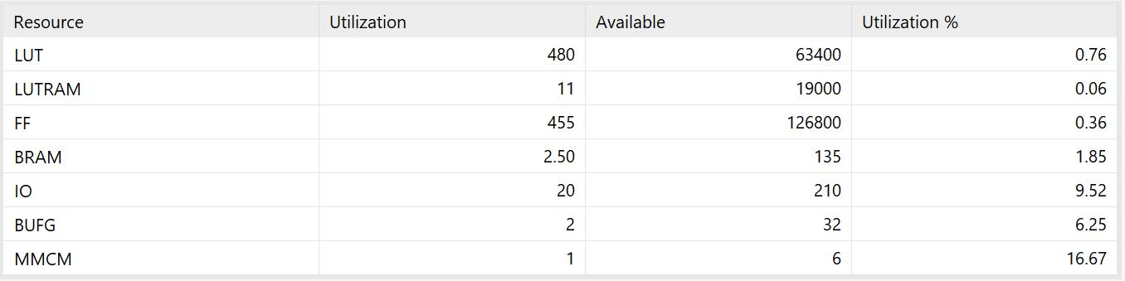

**Figure 1: FPGA Utilization from Implementation of Project**

**Conclusion**

This lab was a great way for students to practice all the skills learned in the course as well as analyze existing code to create a project that works on an FPGA. It also was a good way to introduce students to using new IO (VGA). This will most likely be a part of the final project so this lab will be very beneficial to students.